Time Manager

Functional Specification Document

Version 1.0: 9/29/2017

All Right Reserved ©

1 Introduction 1

1.1 About 1

# 

# Introduction

## About

The Time manager application consists of the following:

* Clock
* Alarm Clock
* Task time keeper

This application will play music when the alarm is set and will display the time between the alarm and the target time is a colored pie, to track the tasks that need to be done until the target time is reached.

# User Interface

The application consists with the following screens

## Home Screen

This screen will be displayed when the application is launched and will be displayed when the application is idle mode.

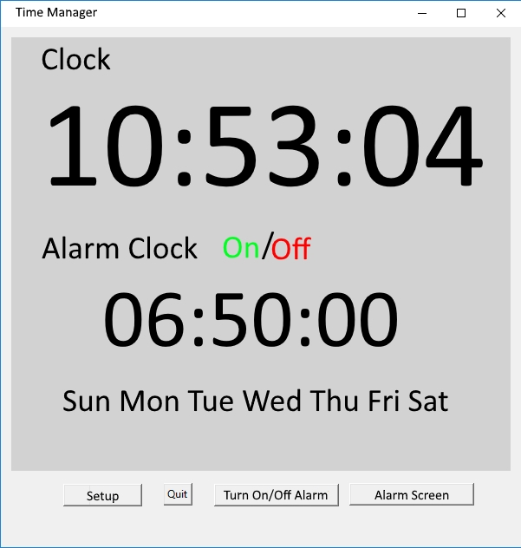

7

6

5

4

3

Figure 1: Home Screen

### Windows properties

|  |  |  |  |
| --- | --- | --- | --- |
| # | Property | value | Usage |
| 1 | Width | 600 | Windows width |
| 2 | Height | 800 | Windows height |
| 3 | Clock | Current time | The current time will be displayed |
| 4 | Alarm Clock On/Off | On or Off | When the alarm clock is active, the display will show “Alarm Clock On”. When the alarm clock is not active the display will show “Alarm Clock Off”. |
| 5 | Alarm Clock | Alarm Time | The alarm time will be displayed |
| 6 | Days of the week | Each day | A day that the alarm should be activated, will be displayed in black color and a day that the alarm should be deactivated will greyed out. |
| 7 | Buttons |  | **Setup** – Open the setup window see section ‎2.2  **Quit** – Close the application (Alarm will not work)  **Turn On/Off Alarm** – manually turn the alarm off or on  **Alarm Screen** – open alarm screen (if alarm is active) |

## Setup Screen

In the setup screen one can setup the alarm, the tasks to track and the target time.

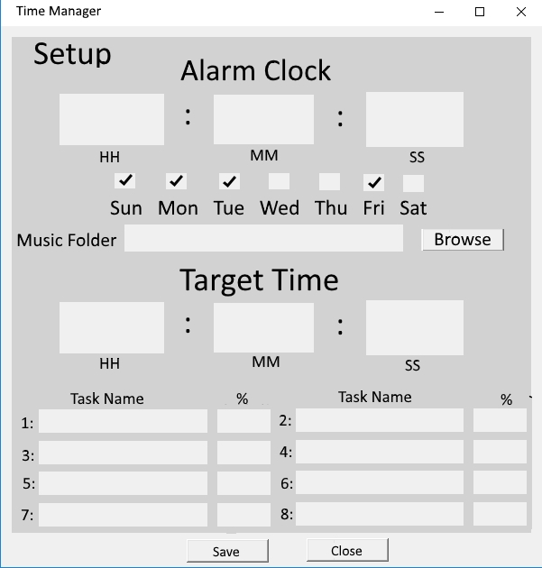

8

7

6

5

4

3

Figure 2: Setup Screen

### Windows properties

|  |  |  |  |
| --- | --- | --- | --- |
| # | Property | value | Usage |
| 1 | Width | 600 | Windows width |
| 2 | Height | 800 | Windows height |
| 3 | Alarm Clock | Alarm Time | Setup the alarm time |
| 4 | Days of the week | check | Check the days that the alarm will be activated |
| 5 | Music Folder | path | Browse to the selected folder where the music files are stored |
| 6 | Target time | time | The time that the tasks should be done |
| 7 | Tasks | text | Task names and percentage. The percentage of all tasks should sum to 100. This is the time interval percentage from the time of alarm to the target time. |
| 8 | Buttons |  | **Close** – Close the window, navigate back to the home screen. All unsaved data will be erased. Pop up a warning message see section ‎2.3  **Save** – save the new configuration |

### Configuration file

The configuration will be saved in a configuration file and will be used every time the application is launched.

## Warning Screen

Closing a page without saving the changes will trigger a pop up window

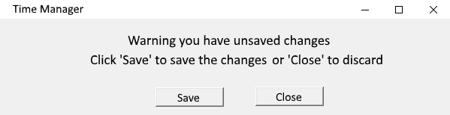

3

4

Figure 3: Warning Screen

### Windows properties

|  |  |  |  |
| --- | --- | --- | --- |
| # | Property | value | Usage |
| 1 | Width | 600 | Windows width |
| 2 | Height | 150 | Windows height |
| 3 | Text | Text | Warning you have unsaved changes. Click ‘Save’ to save the changes or ‘Close’ to discard |
| 4 | Buttons |  | **Close** – Close the window and discard changes and close windows – navigate to home screen  **Save** – save changes and close windows – navigate to home screen |

## Alarm Screen

When the alarm is triggered, the application will play the music from the music folder. In addition, the Alarm screen will be displayed, presenting the current time and the target time.

The pie will present the tasks’ name and their corresponding percentages. The pie will be colored when the time advances, until the target time is reached. When the target time is reached, the pie will be totally filled with colors.

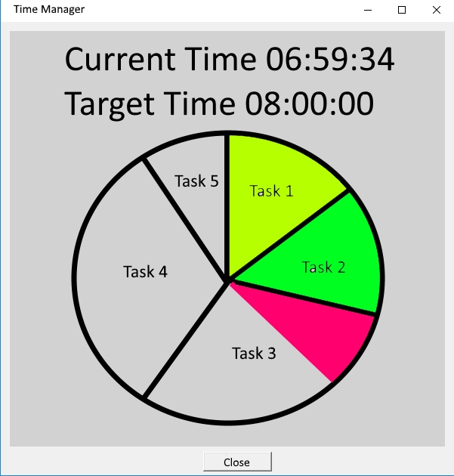

6

5

4

3

Figure 4: Alarm Screen

### Windows properties

|  |  |  |  |
| --- | --- | --- | --- |
| # | Property | value | Usage |
| 1 | Width | 600 | Windows width |
| 2 | Height | 800 | Windows height |
| 3 | Clock time | Current Time | The current time |
| 4 | Target time | time | The time when the pie will be totally filled with color. |
| 5 | Pie | Text and colors | Displays the tasks in the pie according to their percentage. The pie will be filed will color (clockwise) when time advances until the all pie is filled with color. This is when the target time is reached. |
| 6 | Buttons |  | **Close** – Close the window, navigate back to the home screen |